
St James CE Primary Academy
Together through faith we will aspire to grow in our understanding of ourselves, in our abilities and in our knowledge of God’s wonderful diverse world.

Behaviour Policy 2026 - 2027

At St James C of E Academy School our behaviour ethos is underpinned by our strong Christian ethos.
These values are not just found within the Christian faith but across the representation of faiths we
have within the academy.
- Love
- Trust
- Respect
- Friendship
- Honesty and Truthfulness
- Perseverance
At St James C of E Academy School, we aim to create a safe, calm and happy environment for all school community members. We want everyone to feel valued, respected, confident and safe. This policy is written for every member of the academy community to allow a universal understanding of the rationale that underpins it. We believe Restorative Approaches is a fundamental component in helping the School Community achieve this aim. Restorative Approaches offer a framework that enables young people to develop their social and communication skills.
Our Policy –
• Aims to articulate the central values, rights and responsibilities which underpin the management and development of student behaviour within our school.
• Will have as its central pillar the Principles of Restorative Justice. The Restorative Justice approach will provide an alternative to the belief that punishment will change behaviour
and achieve compliance.
• Will use Restorative Justice as an educative approach, to help those involved to learn how to change. Restorative Approaches will underpin our Positive Relationship Policy and offer an alternative to the traditional responses to challenging behaviours.
• Is written in the belief that an understanding, shared throughout the school, of principles, procedures and practices, is the most effective method of achieving a united school community of which all its members can be proud.

PHILOSOPHY –
1. We believe that good behaviour is an integral part of the learning process. Individual students have the right to work and develop in an atmosphere of respect, trust, security, honesty and openness – where positive relationships are valued within the school and the wider community.
2. The key elements in this philosophy are:
o Clear, shared learning goals;
o Creation of a psychologically safe and caring environment;
o Enabling, recognising and celebrating individual achievement;
o Tolerance and understanding of others.
3. Positive relationships (between students, their peers and adults) are integral to the effective implementation of this policy.
4. In order to promote the success of this policy, the school will endeavour to ensure an effective partnership between adults at home and at school.
5. The Policy will be applicable in school, on school trips, and also where appropriate when students are representative of the school in their journey to and from school.
6. The Policy will rely on the Principles of Restorative Justice:
o They focus on harm caused by the wrong-doer and actively seek ways of repairing that harm.
o They help create dialogue and communication.
o They are fair, open, and honest; treating all participants with respect.
o Within a safe environment they will allow all participants to engage, learn and gain a shared understanding.
o This should lead to accepting responsibility, reparation, reintegration, restoration, and behavioural (and cultural) change.
o Participants are given the opportunity to openly state their views, listen to others and acknowledge their views.
RIGHTS AND RESPONSIBILITIES
All members of the community of St James CE Primary Academy share the rights to:
- Work safely and productively;
- Share information, skills learned and concepts grasped – without distraction or disruption;
- Have recognition and reward for successes and efforts;
- Have self-esteem enhanced;
- Work in a co-operative manner and treat each other with respect and dignity;
- Welcome visitors and similarly to respect their rights;
- Have equal opportunity to succeed irrespective of race, gender, religion, sexuality, ability or disability (see separate policies).

During establishment phases, teachers will involve their class in the creation of a set of commonly agreed self-regulation tools and, in turn, will ensure these are clearly displayed in classrooms. These will include:

- STAR
S – sitting upright so the speaker knows you are listening.
T – tracking the speaker so they know you are engaged in what they are saying.
A – appreciate what the speaker is saying/has said through nodding, clicks, shine.
R – responding to the speaker by building on, agreeing or disagreeing with what has been said. Sentences stems will be used to support responses. I agree with what ? has said and I also think …, I hear what ? has said but I disagree because …., I agree with ? because ….

- Expectations
Pupils will understand that there a set of expectations which create a psychologically safe classroom. These can include but not limited to:
Mutual respect
Contributions are valued
Feeling safe to make mistakes
Feel appreciated

- Self-regulation
Pupils are greeted by the class teacher or teaching assistant when entering the classroom at the beginning of the day, after break time and after lunchtime. This will give the adult time to identify a child who is dysregulated. Where this is the case, the adult will have a conversation with the child about how they are feeling and where needed use the zones of regulation. Strategies will be put in place to support the child.

LUNCHTIMES AND BREAKTIMES

Lunchtimes and breaktimes can be a point in the day where children can feel overwhelmed and become dysregulated. Lunchtime supervisors will need to identify any child who is showing signs of dysregulation.

TEACHING AND LEARNING
The development of students’ social, emotional and behavioural skills will be encouraged by establishing high expectations in all lessons.
Through regular meetings, both formal and informal, pupils who are identified with more challenging behaviour are provided with additional support and/or changes to curriculum or provision with the focus ultimately on reintegrating the pupil as soon as possible back into the learning environment. Through the restorative process, the school aims to support these young people, helping them to understand their behaviour, the effect it has on their learning and that of others.
The way in which all members of the school community teach and learn from each other when behaviour and attendance is unacceptable, is also influential. As pupils grow through the school there should be regular explicit opportunities for learning about how to act in keeping with the school’s vision and values. Each classroom will have on display Restorative Justice posters and STAR posters to highlight and promote the strategies used within school to support our pupils.

ROLES AND RESPONSIBILITIES
The promotion of positive behaviour is the responsibility of the school community as a whole.
The Local Academy Committee (LAC), Trust Headteacher and Staff are responsible for ensuring that all aspects of the school’s Positive Relationship Policy and its application promote equality for all students. The roles include:
EYFS
Our Reception class has the same expectations of behaviour. We give similar
rewards and sanctions but through the use of visual prompts.
The Role of the Class Teacher
It is the responsibility of the class teachers to ensure that the positive behaviour policy is consistently applied both in the classroom and around the academy.
It is the responsibility of the class teacher to ensure that our values and academy rules are enforced in their class, and that their class behaves in a responsible manner during lesson times.
The class teachers in our academy have high expectations of the children in terms of behaviour, and they strive to ensure that all children work to the best of their ability and succeed.
The class teacher and support staff treat each child fairly and ensures the classroom code is adhered to consistently. The teacher treats all children in their class with respect and understanding.
The class teacher and support staff adhere to the agreed sanctions.
If a child misbehaves repeatedly in class, the class teacher keeps a record of all such incidents following agreed recording system – Behaviour Log.
Where necessary, the class teacher liaises with a named member of SLT and with external agencies, where relevant, to support and guide the progress of each child.
The class teacher reports to parents about the progress of each child in their class, in line with the whole academy policy.
Positive Intervention and Evidence-Gathering Process
Where repeated negative behaviour choices are observed, teachers must employ positive intervention strategies before escalation to the senior leaders.
Teachers should use the Behaviour Evidence Gathering Sheet (Appendix 2) to monitor and record behaviour patterns over a four-week period.
This stage focuses on:
• Identifying Antecedents, Behaviours, and Consequences (ABCs),
• Implementing and recording strategies and adjustments,
• Evaluating the impact and effectiveness of interventions, and
• Gathering evidence to support next steps.
If, after the four-week evidence-gathering period, behaviour does not improve, the teacher must meet with the Trust Headteacher to discuss next steps.
This process ensures early, proactive support is in place, with clear evidence and reflection guiding the next stage of intervention.

The Role of Teaching Assistants and Lunchtime Supervisors
It is the responsibility of all teaching assistants to work with the class teacher to ensure the positive behaviour policy is consistently applied both in the classroom and around the academy.
It is the responsibility of all lunchtime supervisors to ensure the positive behaviour policy is consistently applied both in the classroom during ‘wet dinnertimes’ and around the academy. The agreed sanctions are applied to children who behave in an inappropriate manner during
lunchtimes. These are recorded by the lunchtime supervisors and reported to the class teacher.

The Role of Senior Leaders
There is a staged approach to how we tackle challenging behaviour across the academy (Appendix2) During the academic year of 2026/2027 lead behaviour teacher across the academy is the Trust Headteacher.
It is the responsibility of senior leaders to implement the academy’s behaviour policy consistently throughout the academy. When additional support outside of the academy might be needed, senior leaders will work together to form a behaviour plan outlining ways to address individual needs.
Senior Leaders support the staff by implementing the policy, by setting the standards of behaviour, and by supporting staff in the implementation of the policy. The Trust Headteacher will organise internal exclusions, meet with parents to discuss behaviour and organise possible support from outside agencies.
The Role of the Trust Headteacher
It is the responsibility of the Trust Headteacher to ensure that the academy’s behaviour policy is implemented consistently throughout the academy, to report to the LAC and St. Chad’s Academies Trust when requested. It is also the responsibility of the Trust Headteacher to ensure the overall health,
safety and welfare of all children and staff in the academy.
The Trust Headteacher supports staff and others to implement the policy, by setting the standards of behaviour, and by monitoring the implementation of the policy.
The Trust Headteacher has the responsibility for giving fixed-term exclusions to individual children for serious acts of misbehaviour, persistent disruptive behaviour or failure to respond to correction by members of staff. For persistent disruptive behaviour, repeated or serious acts of anti-social
behaviour, the Trust Headteacher may permanently exclude a child.
Permanent exclusions are only taken after the LAC (Local Academy Committee) have been notified.
The Role of Parents and Carers
Parents and carers are asked to:
• Read and support this policy.
• Let your child know the standards of behaviour you expect from them and how hard we expect them to work.
• Talk to teachers if they have any concerns about their child’s learning and wellbeing.
• Behave respectfully towards those within the academy community both verbally and in written communications.
Parents and carers can do this by:
• Ensuring the regular attendance and punctuality of their children.
• Their child having the correct equipment and uniform.
• Supporting home learning opportunities such as reading, spelling practice and Times Table Rockstars.
The Role of the LAC (Local Academy Committee)
The LAC has the responsibility of setting down these general guidelines on standards of behaviour and discipline, and of reviewing their effectiveness. The LAC members support the Trust Headteacher in carrying out these guidelines.

Code of Conduct
The academy has a zero tolerance for verbal or written abuse towards its members of staff from children or members of the wider community. Adults who are verbally abusive towards staff will immediately be asked to leave the academy premises and the Police informed, if necessary.
Evidence of written abuse may be used in conjunction with further action by the academy and the Police, if necessary.
The use of Restorative Approaches at St James CE Primary Academy.
The approach will require all staff working with our students to be aware of the principles and language of Restorative Justice. Staff will use these principles to resolve situations in their classes, corridors, and elsewhere in the academy. The principles and use of Restorative Approaches will be a regular feature in the school’s Continuing Professional Development programme, both at the
beginning of the school year and where appropriate at other times.
The Restorative Questions:
- λ What happened?
λ What were you feeling / thinking at the time?
λ What do you think / feel about it now?
λ Who has been affected by what has happened?
λ In what way?
λ What impact has this incident had on you and on others?
λ What has been the hardest thing for you?
λ What do you think needs to happen to make things right?
λ What do we need to do make sure this doesn’t happen again?
The questions are neutral and non-judgemental, they are about the wrong-doer’s behaviour and its effect upon others, and they are open questions which require an answer. They take everyone from the past (what happened) to the future (repairing harm) and require people to reflect on who has been affected. They are likely to help the wrongdoer develop some empathy for those affected.
Posters highlighting these questions will be displayed in all classrooms.
How to use the Restorative Questions:
The Restorative Approach model can be applied in a number of ways, ranging from informal work in corridors and classes to formal conferences with the wrong-doer and the harmed including working with whole classes.
Restorative Chat – informal chat using restorative questions, this does not include formal referral, preparation, contract or debrief but should/may include a follow-up; individual member of staff takes initiative and leads process.
Corridor/Impromptu Conference – informal conference that does not include formal preparation, but may include an informal contract and a follow up; individual member of staff takes initiative and leads process.
Circle or Classroom Conference – a more-structured conference that requires a degree of pre-conference preparation and, possibly, a contract, debrief and a follow-up session. Referral for support can be made to the Trust Headteacher for the students concerned.
N.B. Restorative Justice Interventions that tackle behaviours that exceed those low-level norms should be recorded as appropriate on the school’s behaviour logs.

REWARDS AND SANCTIONS
The academy believes that rewards are much more effective than punishment in encouraging and motivating students and should be used as a proactive incentive for success. The Reward System at St James CE Primary Academy is designed to target outstanding work and effort, positive
learning behaviours and positive social behaviours.
Examples of incentives for success
- a smile and verbal praise from adults in the class
- stickers
- Class Dojo rewards. Points will be given for:
Perseverance
Manners
Supporting others
Pride in their learning (inline with the presentation policy)
- Class Dojo message home to parents
- visit to share the reason for praise with the Trust Headteacher
- visit to share the reason for praise with the subject leader
- nomination for class STAR of the week.
Likewise, wherever possible Restorative Justice Conversations should initially be used in preference to sanctions to manage inappropriate behaviour; where this is not possible or where it has failed, an appropriate sanction may be negotiated with the wrong-doer or applied by the adult dealing with the incident.
Examples of sanctions that can be negotiated or set for the wrong-doer
- a verbal apology given to the injured party
- apology card written by the wrong doer
- supervised lunches/break times
- lunch time intervention
- learning for the lesson takes place in another room.

Fixed Term Exclusions
Only the Trust Headteacher has the power to exclude a child from the academy. They may exclude a child for one or more fixed periods, for up to 45 days in any one academic year. Parents have the right to make representation to the LAC but the LAC cannot overturn the decision, neither can they
convert a fixed term exclusion into a Permanent Exclusion.
Permanent Exclusion
A child should only be permanently excluded from the academy if they have seriously or persistently broken the academy’s behaviour policy and it would seriously harm the education or welfare of themselves or others if they stayed in the academy.
Parents have the right to challenge the exclusion by making representation to the LAC.
If the LAC appeals panel decided that a child should be reinstated, the academy must comply with this ruling.
If the LAC upholds the decision, a parent/carer can appeal to an Independent Appeal Panel (IAP)

Appendix 1 -Behaviour Flow Chart

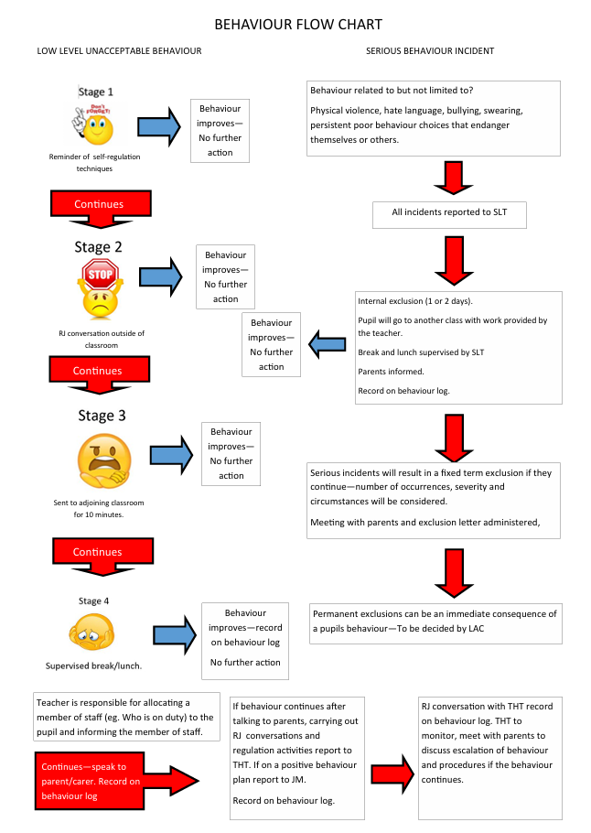

Appendix 2 – Behaviour Evidence Gathering Sheet

Behaviour Evidence Gathering Sheet – 4 Week Period

This sheet is to be used over a 4-week period to gather evidence on behaviours displayed, identify potential triggers, monitor strategies used and evaluate their effectiveness. The information gathered will support next step and form the foundation of a Positive Behaviour Plan if needed.

Pupil Details
Pupil Name
Class/Teacher
Start Date
End Date

Weekly Behaviour Evidence
Week | Behaviours observed | Possible triggers | Strategies used | Impact/outcome | Next steps/  adjustments
Week 1
Week 2
Week 3
Week 4

Appendix 3
Signs of emotional dysregulation



