Writing at St James C.E. Primary Academy
Beginning Planning:
- Choose a quality text – suggested quality texts are given for each year group in the ‘Year Group Expectations’. A quality text has strength and depth of character. It has challenging vocabulary for the children to explore.
- Think about which writing genres must be covered throughout the year (e.g. recounts, instructions, newspaper reports) and ensure that your quality text choices lend to the writing genres. We should aim to produce multiple pieces of writing from one text (fiction, non-fiction and poetry). You should have a copy of the ‘Year Group Writing Genres’ which outline the genres which must be covered in each year group.
- Once we know what text we are covering and what writing genres we are covering, we need to look at the grammar and punctuation we need to recap and which grammar and punctuation we need to introduce. The grammar and punctuation which needs to be taught in each year group is outlined below in the ‘Year Group Expectations’ – this is taken from the National Curriculum. From this, we select the grammar that fits with the genre we are teaching – this provides context for the grammatical features. Grammar is to be taught throughout the year, not by term as shown below. Choose how to teach grammar so that it fits with your genre coverage.
For example – For a formal letter, I must teach fronted adverbials and formal language. We also need to think about our children and what they might need to recap. For example, if their sentence structure is not secure, we know that we need to spend some time on this.

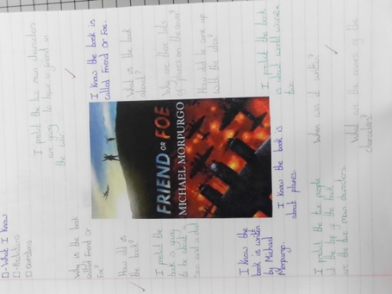
The process:
We should begin a new text with a hook – this could be prediction and questioning using the front cover, or an object arriving in class, a letter from a character or chapter titles.
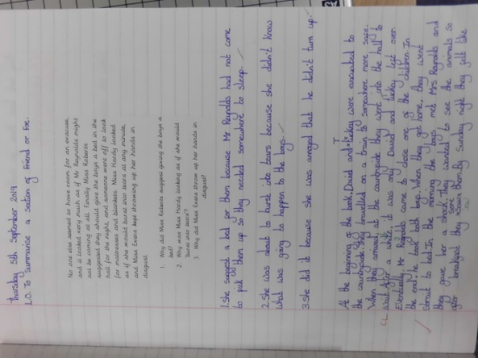
As we introduce a text to the children, we need to provide them with the cultural capital. For example, if we are teaching ‘Friend or Foe’, we need to provide the children with images of WWII London, giving information and images about the Blitz as well as images of the countryside. Do they know when the book is set? Who was the monarch at the time? What are the differences between then and now? Can we draw any similarities between this book and another we have read before? Talk about the author, do we know any other books written by Michael Morpurgo?
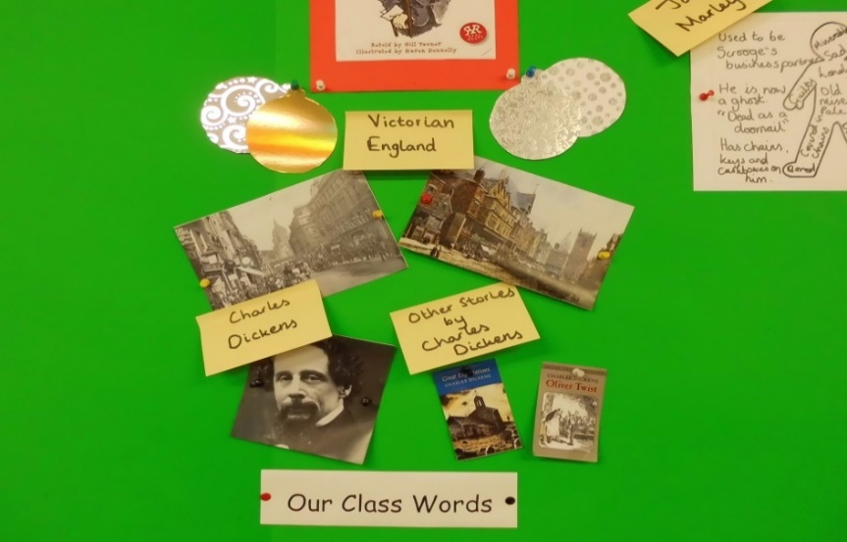

A cultural capital section on your English Working Wall is also a good way of ensuring that children are constantly reminded of the context of the book. This can be referred to regularly throughout the duration of the study of the text. I have included an example of a cultural capital section from an ‘A Christmas Carol’ display.

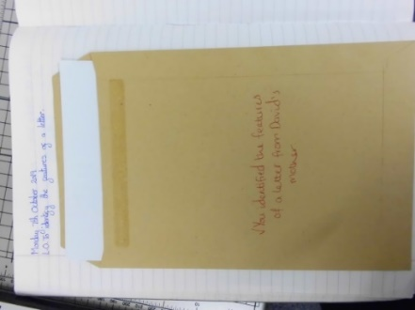
Next, we will read and discuss the text, targeting questions at the children to teach the reading skills (retrieval, inference, prediction, vocabulary etc.) Year group reading skills can be found on the separate document from the National Curriculum. After reading the text, children can summarise the text.
Now, we should begin building towards our piece of writing by looking at examples of the genre (e.g. identifying the features of a letter).
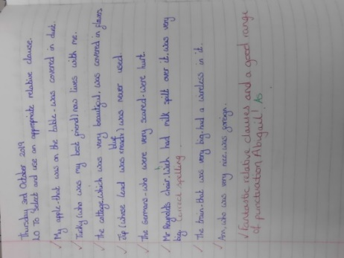
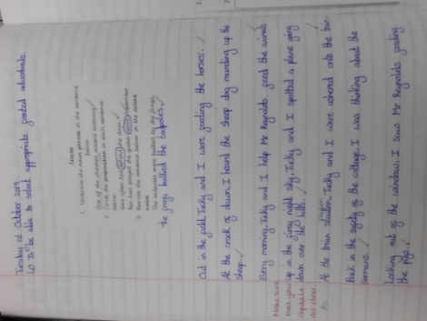

Once we know what features our genre has, we can start practising those features (e.g. a lesson on relative clauses, a lesson on fronted adverbials.) All should be taught in context.

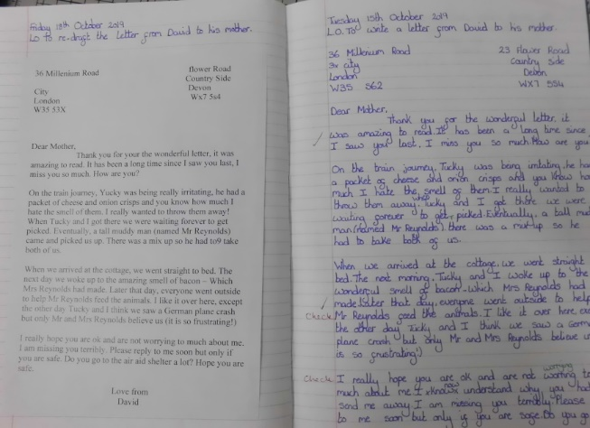

Finally, the children will have enough information and understanding to plan, write and re-draft a quality piece of writing. We will produce a quality piece of writing of length every 2-3 weeks. The final piece does not require writing up in ‘best’.

Year Group Expectations
Reception
Aspect | Autumn | Spring | Summer
Handwriting  (Taught Daily) | - Use some of their print and letter knowledge in their early writing. For example: writing a pretend shopping list that starts at the top of the page; writing ‘m’ for mummy. | - I can form some lower and upper case letters  - I can write some or all of my name | - Hold a pencil effectively in preparation for fluent writing – using the tripod grip in almost all case
Spelling | Spelling should be taught through modelling in every lesson, focusing on the teaching of phonic sounds, then year group specific words (CEWs) and high frequency words. Errors should be addressed through marking and children must be held accountable for these errors. Spelling rules must be taught and applied by the children in their writing. Spelling lists to be sent home for the children to practice throughout the year.
Composition | - Motivate children to write by providing opportunities in a wide range of ways. Suggestions: clipboards outdoors, chalks for paving stones, boards and notepads in the home corner. Children enjoy having a  range of pencils, crayons, chalks and pens to choose from. Apps on tablets enable children to mix marks,  photos and video to express meanings and tell their own stories. Children are also motivated by simple home-made books, different coloured paper and  paper decorated with fancy frames. | - Help children to learn to form their letters accurately. First, they need a wide-ranging programme of physical skills development, inside and outdoors.  Include large-muscle co-ordination: whole body, leg, arm and foot. This can be through climbing, swinging, messy play and parachute games etc. Plan for small muscle co-ordination: hands and fingers. This can be through using scissors, learning to sew, eating with cutlery, using small brushes for painting and pencils  for drawing. Children also need to know the language of direction (‘up’, ‘down’, ‘round’, ‘back’ etc).  - Teach formation as they learn the sounds for each letter using a memorable phrase  - Support children to form the complete sentence before writing. Help children memorise the sentence before writing by saying it aloud. Only ask children to write sentences when they have sufficient knowledge of letter-sound correspondences | - ELG: Writing  Children at the expected level of development will: - Write recognisable letters, most of which are correctly formed; - Spell words by identifying sounds in them and representing the sounds with a letter or letters; - Write simple phrases and sentences that can be read by others.
Grammar | - I use the personal pronoun ‘I’ within a spoken sentence. | - I can use the pronoun I in a written sentence  - I can develop pronouns to include he, she...  - I can use ‘was’ correctly | - Model how you read and re-read your own writing to check it makes sense.
Punctuation | - I can use a capital letter for the start of my name | - I can form some upper case letters | - I leave spaces between words.  - I use a capital letter for the start of a sentence.
Vocabulary | - Help children to join in with refrains and learn some verses by heart using call and response.  - When singing songs by heart, talk about words in repeated phrases from within a refrain or verse so that word boundaries are noticed and not blurred: “Listen carefully, what words can you hear? Oncesuppona time: once – upon – a – time.” | - Model noticing how some words sound: “That poem was about a frog on a log; those words sound a bit the same at the end don’t they? They rhyme.”  - In poems and rhymes with very regular rhythm patterns, pause before the rhyming word to allow children to join in or predict the word coming next.  - Encourage children to have fun with rhyme, even if their suggestions don’t make complete sense. Choose a few interesting longer words from the poem, rhyme or song and clap out their beat structure, helping children to join in with the correct number of ‘claps’. | - Read and re-read selected stories.  - Show enjoyment of the story using your voice and manner to make the meaning clear.  - Use different voices for the narrator and each character. Make asides, commenting on what is happening in a story: “That looks dangerous – I’m sure they’re all going to fall off that broom!”  - Link events in a story to your own experiences.  - Talk about the plot and the main problem in the story.  - Identify the main characters in the story, and talk about their feelings, actions and motives.  - Take on different roles in imaginative play, to interact and negotiate with people in longer conversations.  - Practise possible conversations between characters.
Suggested ‘quality’ texts. | -The Lighthouse Keeper’s Lunch  - This Is Our House  -The Gruffalo  - Owl Babies  - Goldilocks and the Three Bears  -The Three Little Pigs  -Three Billy Goats Gruff  - Little Red Riding Hood  - Happy Birthday, Moon!  - The Snorgh and the Sailor  Texts other than these can be used, but they must be ‘quality’ and you must be able to use them for the writing genres you need to cover.  How do you know if a text is a ‘quality’ text?  -The language and themes should challenge your children, but not be too far advanced that they cannot access it.  -It should contain strong themes which the children can relate to.  -It should have strong characters with clear personality and depth.  -The themes might relate to or add to their cultural capital (knowledge they already have or need to have).

Year 1
Aspect | Autumn | Spring | Summer
Handwriting  (Taught Daily) | - I sit correctly at a table, holding a pencil comfortably.  - I form the digits 0-9 correctly. | - I form lower case letters in the correct direction, starting and finishing in the right place. (cursive -kicks and flicks). | - I name the letters of the alphabet in order.  - I form capital letters.
Spelling | Spelling should be taught through modelling in every lesson, focusing on the teaching of year group specific words (CEWs) and high frequency words. Errors should be addressed through marking and children must be held accountable for these errors. Spelling rules must be taught and applied by the children in their writing. Spelling lists to be sent home for the children to practice throughout the year.
Composition | - I say a sentence out loud before I write it down (hold a sentence). | - I plan my writing by saying what I am going to write about. (build a sentence)  - I read my own writing aloud so I can be heard by others and check for sense. (‘Oops, I forgot to put a capital letter after that full stop.’; ‘I used my sounds to help me spell that long word.’) | - I sequence sentences to form short narratives.  (Beginning/middle/end – sentences link and build on from each other – The cat walked down the road. It was bright orange and fluffy. It wanted to get home.)  - I use sequence sentences in chronological order to recount an event/experience. (Basic adverbials for when – First, Then, Next, After that)
Grammar | - I use the personal pronoun ‘I’. | - I use ‘and’ to join ideas within a sentence. (‘I went to the park and played on the swing.’) | - I may attempt to use other conjunctions.  - I make sure that word choices are relevant to the context and I use word banks to support this.  - I begin to use adjectives to add detail to my sentences.
Punctuation | - I leave spaces between words.  - I use a capital letter for the start of a sentence. | - I begin to use the other punctuation such as exclamation and question marks.  - I use a full stop accurately. | - I use capital letters for the names of people, places and day of the week. (Aa)
Suggested ‘quality’ texts. | -Cinder the Bubble-blowing dragon  -The Gruffalo  -Owl Babies  -Goldilocks and the Three Bears  -The Three Little Pigs  -Three Billy Goats Gruff  -How to Hide a Lion  -Stuck  -Toy Story  - The Snorgh and the Sailor  - The King of Tiny Things  Texts other than these can be used, but they must be ‘quality’ and you must be able to use them for the writing genres you need to cover.  How do you know if a text is a ‘quality’ text?  -The language and themes should challenge your children, but not be too far advanced that they cannot access it.  -It should contain strong themes which the children can relate to.  -It should have strong characters with clear personality and depth.  -The themes might relate to or add to their cultural capital (knowledge they already have or need to have).

Year 2
Aspect | Autumn | Spring | Summer
Handwriting  (Taught Daily) | - I use some of the diagonal and horizontal strokes needed to join letters.  - I understand which letters, when adjacent to one another, are best left unjoined.  - I write capital letters (and digits) of the correct size/orientation to one another. | - I use spacing between words that reflects the size of the letters. | - I form lower case letters of the correct size relative to one another.
Spelling | Spelling should be taught through modelling in every lesson, focusing on the teaching of year group specific words (CEWs) and high frequency words. Errors should be addressed through marking and children must be held accountable for these errors. Spelling rules must be taught and applied by the children in their writing. Spelling lists to be sent home for the children to practice throughout the year.
Composition | - I develop stamina for writing by writing for different purposes. (Real and fictional/own and other’s experiences – including simple narratives, poems and recounts). | - I plan and discuss the content of my writing (Jotting down ideas, planning the structure, oral rehearsal of what they want to say, sentence by sentence).  - I evaluate my writing independently, with peers and with my teacher by making simple additions and corrections. (Re-reading to check for sense; verbs used correctly E.g. Pupil writes ‘I sitted under the tree and eated my lunch’ becomes ‘sat and ate’).  - I write, from memory, simple dictated sentences. | - I proof-read to check for errors in spelling, grammar and punctuation. (Will spot most of their own spelling errors quickly. e.g. ‘This should be an exclamation because she’s shouting for help’ ‘I forgot to double the p of stop when adding –ing’).  - I make changes, sometimes independently and sometimes in discussion with an adult, to improve the effect and impact of my writing.
Grammar | - My word choices are thoughtful and sometimes ambitious with specific or technical vocabulary used in non-narrative writing. | - I use expanded noun phrases to describe, expand and specify. (‘the delicate, blue butterfly flew off into the humid, summer sky’).  - I use subordination (using when, if, that or because). (Consistent use of both e.g.: You need to pack your raincoat because it is going to rain later.) | - I use sentences with different forms: statements, questions, exclamations and commands. (‘The colourful butterfly flew from flower to flower’ ‘Where do clouds come from?’ ‘What big eyes you have!’ ‘Sift the flour and mix the other ingredients.’)  - I use co-ordination (using or, and or but). (You remembered your book bag but forgot your lunch).  - I use present and past tenses correctly and consistently including the progressive form. (Consistently makes the correct choice e.g.: ‘She is drumming; she drummed, she was drumming’.)  - I use adjectives, adverbs and expanded noun phrases to add detail and specify.
Punctuation | - I use full stops and capital letters – most are correct. (This will be consistent across a range of dictated and independent writing).  - I mostly use exclamation and questions marks accurately to demarcate sentences. | - I use capital letters for the personal pronoun ‘I’ and for most proper nouns. | - I begin to use commas to separate items in a list.  - I sometimes use apostrophes for singular possession.
Suggested ‘quality’ texts. | - Red Riding Hood  - Jack and the Beanstalk  - The Tear Thief  - Baba Yaga  - Traction Man  - A Squash and a Squeeze  - The Lighthouse Keeper’s Lunch  - The Day the Crayons Quit  - The Tunnel  - Monsters Inc.  - Ice Age  - Bog Baby  Texts other than these can be used, but they must be ‘quality’ and you must be able to use them for the writing genres you need to cover.  How do you know if a text is a ‘quality’ text?  -The language and themes should challenge your children, but not be too far advanced that they cannot access it.  -It should contain strong themes which the children can relate to.  -It should have strong characters with clear personality and depth.  -The themes might relate to or add to their cultural capital (knowledge they already have or need to have).

Year 3
Aspect | Autumn | Spring | Summer
Handwriting  (Taught Daily) | - I increase the legibility, consistency and quality of my handwriting.  - I understand which letters, when adjacent to one another, are best left unjoined.  - I use the diagonal and horizontal strokes that are needed to join letters.
Spelling | Spelling should be taught through modelling in every lesson, focusing on the teaching of year group specific words (CEWs) and high frequency words. Errors should be addressed through marking and children must be held accountable for these errors. Spelling rules must be taught and applied by the children in their writing. Spelling lists to be sent home for the children to practice throughout the year.
Composition | - I write a non-narrative using simple organisational devices such as headings and sub-headings.  - In narrative writing, I develop resolutions and endings. | - I make improvements by proposing changes to grammar and vocabulary to improve consistency. (The accurate use of pronouns in sentences/tenses)  - I look at and discuss different models of writing, taking account of purpose and audience.  - I plan my writing by discussing and recording ideas. (timeline, flowchart, spider diagram, jottings).  - I write a narrative with a clear structure, setting, characters and plot.  - I suggest improvement to my writing through assessing the writing with peers and through self-assessment. | - I identify structure, grammatical features and use of vocabulary for effect in texts.  - I compose sentences using a wider range of structures linked to the grammar objectives. (e.g. tenses – including present perfect/subordinate clauses/co-ordinating conjunctions).  - I begin to organise paragraphs around themes. (Supported by planning then moving to independence).
Grammar | - I use a range of sentences with more than one clause by using a wider range of conjunctions in my writing. (when, if, because, although).  - I recognise and use determiners ‘a’, ‘an’, and ‘the’ appropriately. (an apple; a house; the yellow car/the an a) | - I use the perfect form of verbs instead of the simple past. (I have written it down so we can check what he said) (he has worked hard).  - I understand the purpose of adverbs.  - I use adverbs effectively in my writing.  - I use conjunctions, adverbs and prepositions to express time and cause. (the next thing, next, soon, so, before, after, during, in, because, of). | - Word choices are adventurous and carefully selected to add detail and to engage the reader.  - Detail is added by the expansion of noun phrases before and after the noun and with the use of adverbials.
Punctuation | - I begin to use inverted commas for some direct speech punctuation. | - I use apostrophes for possession with increasing accuracy including plural possession. | - Commas are sometimes used to mark clauses and phrases.
Suggested ‘quality’ texts. | - Tuesday  - Meerkat Mail  - Little Mouse’s Big Book of Fears  - Charlie and the Chocolate Factory  - Cinderboy  - Treasure Island  - An Angel in the Playground  Texts other than these can be used, but they must be ‘quality’ and you must be able to use them for the writing genres you need to cover.  How do you know if a text is a ‘quality’ text?  -The language and themes should challenge your children, but not be too far advanced that they cannot access it.  -It should contain strong themes which the children can relate to.  -It should have strong characters with clear personality and depth.  -The themes might relate to or add to their cultural capital (knowledge they already have or need to have).

Year 4
Aspect | Autumn | Spring | Summer
Handwriting  (Taught Daily) | - I use the diagonal and horizontal strokes that are needed to join letters.  - I understand which letters, when adjacent to one another, are best left unjoined. b/p/s/x | - I increase the legibility, consistency and quality of my handwriting; down strokes of letters are parallel and equidistant; lines of writing are spaced sufficiently so that the ascenders and descenders of letters do not touch.
Spelling | Spelling should be taught through modelling in every lesson, focusing on the teaching of year group specific words (CEWs) and high frequency words. Errors should be addressed through marking and children must be held accountable for these errors. Spelling rules must be taught and applied by the children in their writing. Spelling lists to be sent home for the children to practice throughout the year.
Composition | - I write from memory simple dictated sentences that include words and punctuation taught.  - My narrative writing is organised into clear sequences with more than a basic beginning, middle and end. | - I write a narrative with clear structure, setting, characters and plot.  - I include key vocabulary and grammar choices that link to the style of writing. (e.g.: scientific words/historical words/ words that fit with the context, e.g. science fiction). | - I begin to open paragraphs with topic sentences and organise them around a theme. (Boxing up method independently; five-part story volcano; chunking their writing into paragraphs – they then use this to ensure they have accurate paragraphs and how to demarcate them).  - My endings are developed and close the narrative appropriately relating to the beginning or a change in a character.
Grammar | - I use a range of sentences with more than one clause through use of conjunctions. (‘We put our umbrellas up when it rained’ becomes ‘When it rained, we put up our umbrellas’).  - I use a wider range of conjunctions, such as, although, however, despite, as well as.  - I use the correct article ‘a’ or ‘an’.  - My sentences are often opened in different ways to create effects. | - I use appropriate nouns or pronouns within and across sentences to support cohesion and avoid repetition. (When I was writing about bees, the hive and the queen. I remembered to write ‘they’, ‘it’ and ‘she’ every other time, so that my writing was less repetitive).  - I make improvements to my writing by proposing changes to grammar and vocabulary to improve consistency. (e.g. accurate use of pronouns in sentences; ‘I forgot to put the comma after a fronted adverbial’; realise the spelling of ‘proberbly’ is wrong).  - I use fronted adverbials of place, time and manner, including the use of a comma. (‘Later that day, I went shopping’). | - I use expanded noun phrases with modifying adjectives. (‘The strict teacher with curly hair.’)  - I use adverbs and prepositions to express time, place and cause.  - I build cohesion within paragraphs through controlled use of tenses; subordinating and co-ordinating conjunctions.  - I use Standard English for verb inflections – instead of spoken forms. (‘We were’ – instead of ‘we was’, or ‘I did’ instead of ‘I done’. ‘He is/his’ instead of ‘he’s’).
Punctuation | - All my sentences are correctly demarcated. | - I use the apostrophe for omission and possession. – women’s rights, boys’ cloakroom).  - I secure the use of punctuation in direct speech-, including a comma after the reporting clause. (The conductor shouted, “Sit down!”) | - I almost always use commas for fronted adverbials.
Suggested ‘quality’ texts. | - Fair’s Fair  - Ice Palace  - Stone Age Boy  - Iron Man  - Voices in the Park  - How to Train your Dragon  - The Real Story of the Three Little Pigs  - Wind in the Willows  Texts other than these can be used, but they must be ‘quality’ and you must be able to use them for the writing genres you need to cover.  How do you know if a text is a ‘quality’ text?  -The language and themes should challenge your children, but not be too far advanced that they cannot access it.  -It should contain strong themes which the children can relate to.  -It should have strong characters with clear personality and depth.  -The themes might relate to or add to their cultural capital (knowledge they already have or need to have).

Year 5
Aspect | Autumn | Spring | Summer
Handwriting  (Taught Daily) | - I choose which shape of a letter to use when given choices and deciding, as part of my personal style, whether, or not, to join specific letters.  - I choose the writing implement that is best suited for a task (e.g. quick notes, letters).
Spelling | Spelling should be taught through modelling in every lesson, focusing on the teaching of year group specific words (CEWs) and high frequency words. Errors should be addressed through marking and children must be held accountable for these errors. Spelling rules must be taught and applied by the children in their writing. Spelling lists to be sent home for the children to practice throughout the year.
Composition | - My writing shows that I aim for a range of audiences and the purpose of my writing is to inform, entertain or persuade.  - I organise writing into paragraphs to show different information or events.  - (TIP TOP – Time, Place, Topic, Person Speaking) –Paragraphs can be extended or developed – main point, topic, event, idea with an explanation or additional detail. | - I link ideas within paragraphs (connecting adverbs and adverbials for time [when]; place [where]; how [as/with].  - I develop characters through action, description and dialogue. (Correct and effective use of speech. “Well done, you can use speech marks correctly!” exclaimed the teacher proudly. Description of action through well-chosen adjectives, verbs and adverbs.).  - I add well-chosen detail to interest the reader (Expanded noun phrases – ‘the small playground with the horizontal climbing wall…; the north coast beaches with the best surf…; a tiny kitten with its eyes barely open…’). | - My settings are used to not only create atmosphere, but also to indicate a change.  - Models from my reading are often used or integrated into my writing.  - I manage shifts in time and place effectively and guide the reader through my text.
Grammar | - I ensure the correct and consistent use of tense throughout a piece of writing.  - I start sentences in different ways (-ed/-ing/simile openers, adverbials, conjunctions, not with the pronouns I, He, She, They, It, Him, Her etc. or The).  (Adverbials of time – Later, When the, As the dawn broke,)  (Adverbials of place – nearby, Inside, On top of, Over the rainbow, In a nearby village,)  (Manner – as quick as a flash, with legs swinging in the air,).  - I use a thesaurus for alternative word choices. | - I use stylistic devices to create effects in writing (simile, metaphor, personification).  - I use modal verbs or adverbs to indicate degrees of possibility (There might be… It could be… we may be… sometimes… possibly… occasionally…).  - I use relative clauses beginning with who, which, where, when, whose, that or with an implied (i.e. omitted) relative pronoun (Drop-in sentence).  - I suggest changes to vocabulary, grammar and punctuation to enhance effects and clarify meaning. | - I use the perfect form of verbs to mark relationships of time and cause (e.g. She has gone on holiday and is not back yet. The coach has left without you because you have just arrived late).  - I choose words for deliberate effect and I use them thoughtfully and with precision.
Punctuation | - I use commas to clarify meaning or avoid ambiguity in writing. | - I use colons to introduce a list.  - I use inverted commas and other punctuation to accurately indicate direct speech. | - I use brackets, dashes or commas to indicate parenthesis – Outside I was smiling (inside I was angrier than a bull about the charge).
Suggested ‘quality’ texts. | - Kensuke’s Kingdom  - The Lion, the Witch and the Wardrobe  - Alice in Wonderland  - Who let the God’s Out?  - Shackleton’s Journey  - Beowulf  - The Hobbit  - Fantastic Beasts  Texts other than these can be used, but they must be ‘quality’ and you must be able to use them for the writing genres you need to cover.  How do you know if a text is a ‘quality’ text?  -The language and themes should challenge your children, but not be too far advanced that they cannot access it.  -It should contain strong themes which the children can relate to.  -It should have strong characters with clear personality and depth.  -The themes might relate to or add to their cultural capital (knowledge they already have or need to have).

Year 6
Aspect | Autumn | Spring | Summer
Handwriting  (Taught Daily) | - I produce legible joined handwriting and develop my own personal fluent joined handwriting style (join/not join specific letters – loops)
Spelling | Spelling should be taught through modelling in every lesson, focusing on the teaching of year group specific words (CEWs) and high frequency words. Errors should be addressed through marking and children must be held accountable for these errors. Spelling rules must be taught and applied by the children in their writing. Spelling lists to be sent home for the children to practice throughout the year.
Composition | - I use a thesaurus to develop word understanding and build a bank of antonyms and synonyms. | - I use paragraphs correctly so that each one has a clear topic, and has a signal of change in time, place or event (TIP TOP).  - I adapt the grammar and vocabulary used in my writing to suit the audience and purpose. (Choose appropriate form and register/structure/layout).  - I create atmosphere and describe settings – I use antonyms and synonyms to enhance the description.  - I describe and integrate dialogue to convey character and advance the action (use of inverted commas, mostly correctly).  - I add detail to my writing by using expanded noun phrases to add precision, detail and qualification. | - My second drafts show evaluative and reflective thinking which is evidenced by thoughtful and effective changes made to create effects and to impact on the reader.  - My writing is evaluated as a matter of course and proof reading ensures a high level of accuracy.
Grammar | - I use the correct tense throughout a piece of writing.  - I use modal verbs mostly appropriately to suggest degrees of possibility (could, would, might).  - I add precision, detail and qualification using prepositional phrases and adverbs.  - I effectively draft my work so that I enhance meaning and adapt my grammar choices for effect. | - I use a range of cohesive devices*, including adverbials, within and across sentences and paragraphs (pronouns/adverbials, conjunctions, similes,-ing, -ed, adverb openers/repetition of key words for effect/ prepositional phrases/tenses are secure/ellipses in narratives).  - I ensure correct subject verb agreement in singular and plural. E.g. was – I (one person) were – we (more than one – the children were).  - I use a wide range of clause structures, sometimes varying their position within the sentence. (relative clauses/embedded clauses/subordinate and coordinating clauses/ adverbials/ prepositional clauses).  - I use structures typical of very formal speech. (Subjunctive forms – If I were/ were they to come, or question tags – he is your friend, isn’t he?). | - I use modal verbs and adverbs to position an argument as well as to indicate degrees of possibility, probability and certainty.  - I use a range of verb forms to create more subtle meanings.  - I use the passive voice to present information with a different emphasis (I broke the window in the greenhouse – The window of the greenhouse was broken).  - My vocabulary choices are imaginative and words are used precisely and appropriately to create impact and enhance meaning.
Punctuation | - I can mostly use commas correctly to mark phrases and clauses – clarify. | - I make some correct use of a further range of punctuation across a range of writing. (colons to start lists; semi-colons to separate items in lists and hyphens to emphasise ideas/ use of semi-colons/colon to mark clauses – It’s raining; I’m fed up)  - I can use punctuation for parenthesis, mostly correctly. (Brackets, commas, dashes).
Suggested ‘quality’ texts. | - Macbeth  - Romeo and Juliet  - The Giant’s Necklace  - Eragon  - The Boy in the Striped Pyjamas  - Erica’s Story  - Rose Blanche  - Pig Heart Boy  - A Christmas Carol  Texts other than these can be used, but they must be ‘quality’ and you must be able to use them for the writing genres you need to cover.  How do you know if a text is a ‘quality’ text?  -The language and themes should challenge your children, but not be too far advanced that they cannot access it.  -It should contain strong themes which the children can relate to.  -It should have strong characters with clear personality and depth.  -The themes might relate to or add to their cultural capital (knowledge they already have or need to have).

